Design report

# *Temporary* Planning

## Due Tuesday 26-04-2016

|  |  |  |
| --- | --- | --- |
| **Task** | **Description** | **Assignee** |
| Superficial system level description | Describe the algorithm/strategy (searching procedure) very generally. Options: beide zoeken & droppen, apart, verkennen & verzamelen.  Describe the robot’s components very generally. | Tim  Loek |

## Due Sunday 01-05-2016

|  |  |  |
| --- | --- | --- |
| **Task** | **Description** | **Assignee** |
| Finish system level description |  |  |
| Finish test & integration |  |  |
| Finish detailed specification |  |  |
| Finish planning |  |  |

# System level description

## Problem description

Our group was asked to design and program two robots, using a number of provided materials, which can execute a number of research tasks on Venus. The robots need to drive around on the planet and find as much research samples as possible in minimal time, while avoiding natural obstacles such as cliffs and hills. To simplify this assignment, a very abstract material model of Venus was made which will be used to test the behaviour of the robots. The model is summarized in the table below:

|  |  |  |
| --- | --- | --- |
| **Object** | **Known properties** |  |
| *Boundary*  Black tape | Absorbs infrared light. | C:\Users\hyper\Desktop\boundary.png |
| *Cliff*  Black tape | Absorbs infrared light. | C:\Users\hyper\Desktop\cliff.png |
| *Hill*  30cm high | Reflects ultrasound.  Absorbs infrared light. | C:\Users\hyper\Desktop\mountain.png |
| *Rock sample*  White cardboard  2x2x2cm | Reflects infrared light. | C:\Users\hyper\Desktop\rock.png |
| *Lab*  Box with ramp  2.5cm high  20x20cm floor area | Reflects ultrasound. | C:\Users\hyper\Desktop\lab.png |

Translating the problem statement in terms of this material model, the robots need to find and pick up the rock samples and drop these in the research lab while avoiding the hills, cliffs and boundary. The robots have to communicate with each other in order to complete this task as efficiently as possible.

## Strategy

## The robot

The provided robot is based on the ‘Parallax Shield Kit’, which contains a basic metal construction, an Arduino controller, a gripper and powered wheels. On top of this, the robot has an ultrasonic distance sensor, an additional breadboard and a wireless communication module.

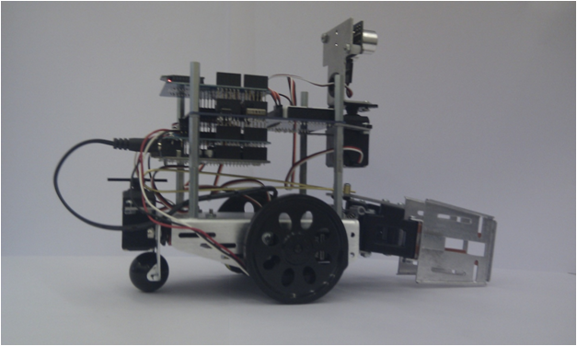

In order to be able to succesfully execute the strategy described above, the robot needs to fulfill the following requirements:

* It can drive around.
* It can pick up and drop research samples.
* It can communicate with other robots for efficiency.
* It has a mechanism to detect hills, cliffs, research samples, the research lab and the boundary of the given area.

The first, second and third conditions are easily fulfilled, since the provided ‘bare’ robot contains powered wheels, a gripper, and a communication module. For the last condition though, an additional sensor may be needed. The hills can easily be detected by the ultrasound distance sensor. This cannot be used for the cliffs, boundaries and samples though, because these do not have a sufficient height. The only known property of these objects which can be used to detect and distinguish them is the infrared reflectivity. Therefore it was decided to add multiple infrared reflection sensors to the robot (marked in red in the picture, to distinguish it from the components included in the basic kit). These sensors can also be used to find the research lab. The robot and its core components are summarized in the graph below:

A more detailed description of these core components and their positions will be given in the next section.

## Detailed specification of the components

Describe positions of sensors/actuators (+ how many), include datasheets and specifications.

## Test and integration plan

## Planning